OS Upgrades:
We will discuss about scenarios where you might have to take down nodes as part of your cluster, say for maintenance purposes like upgrading a base software or applying patches like security patches, etc. on your cluster.
We will see the options available to handle such cases. you have a cluster with a few nodes and pods serving applications. What happens when one of these nodes go down? Of course, the pods on them are not accessible. Now, depending upon how you deploy those pods, your users may be impacted. For example, since you have multiple replicas of the pod, the users accessing the blue application are not impacted as they are being served through the other blue pod that's online.
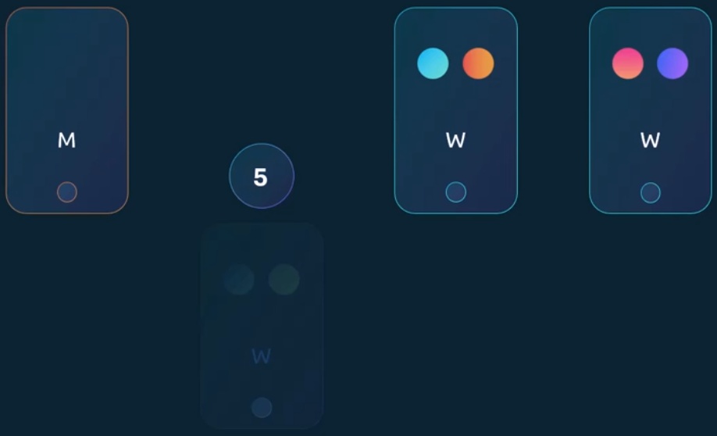
However, users accessing the green pod are impacted as that was the only pod running the green application. Now, what does Kubernetes do in this case? If the node came back online immediately, then the kube control process starts and the pods come back online. However, if the node was down for more than five minutes, then the pods are terminated from that node. Well, Kubernetes considers them as dead.
If the pods were part of a replica set, then they are recreated on other nodes. The time it waits for a pod to come back online is known as the Pod eviction timeout, and is set on the controller manager with a default value of five minutes. whenever a node goes offline, the master node waits for up to five minutes before considering the node dead.
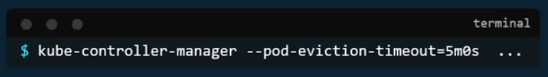
When the node comes back online after the pod eviction timeout, it comes up blank without any pods scheduled on it.

Since the blue pod was part of a replica set, it had a new pod created on another node. However, since the green part was not part of a replica set, it's just gone.

Thus, if you have maintenance tasks to be performed on a node, if you know that the workloads running on the node have other replicas, and if it's okay that they go down for a short period of time, and if you're sure the node will come back online within five minutes, you can make a quick upgrade and reboot. However, you do not for sure know if a node is going to be back online in five minutes. Well, you cannot for sure say it is going to be back at all.
There is a safer way to do it. You can purposefully drain the node of all the workloads so that the workloads are moved to other nodes in the cluster. Well, technically they are not moved. When you drain a node, the pods are gracefully terminated from the node that they are on and recreated on another. The node is also cordoned or marked as un schedulable, meaning no pods can be scheduled on this node until you specifically remove the restriction.
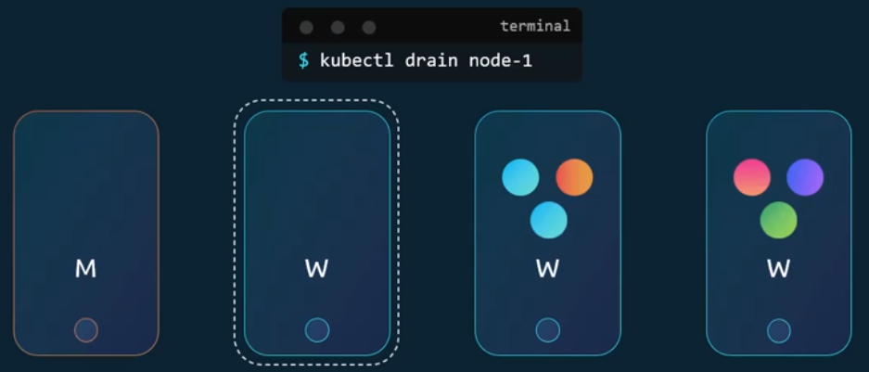
Now that the pods are safe on the other nodes, you can reboot the first node. When it comes back online, it is still un schedulable. You then need to un coordinate so that the pods can be scheduled on it again. Now remember, the pods that were moved to the other nodes don't automatically fall back if any of those pods were deleted, or if new pods were created in the cluster, then they would be created on this node.
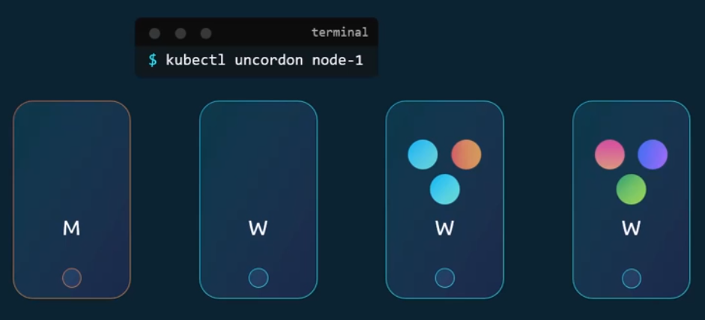
Apart from drain and UN cordon, there is also another command called cordon. Cordon simply marks a node. Un schedulable unlike drain, it does not terminate or move the pods on an existing node. It simply makes sure that new pods are not scheduled on that node.
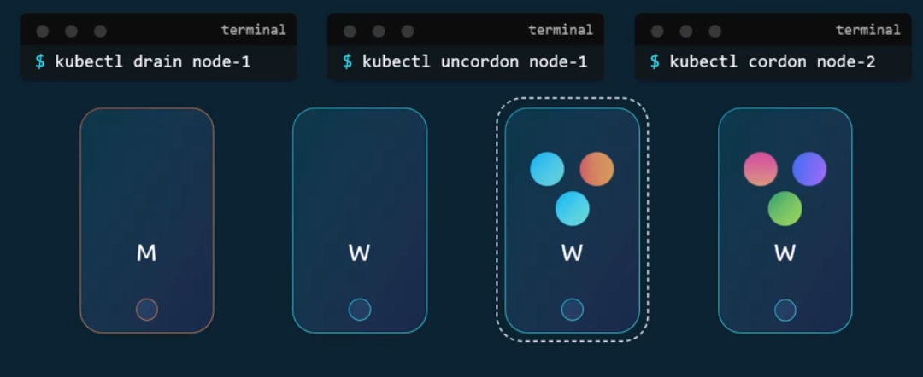

Cluster Upgrade Introduction:
Kubernetes manages its software releases and how different components have their versions. We will keep dependency on external components like etcd and DNS aside for now, and focus on the core control plane components. Is it mandatory for all of these to have the same version? No. The components can be at different release versions, since the kube API server is the primary component in the control plane, and that is the component that all other components talk to. None of the other components should ever be at a version higher than the kube API server. The controller, manager and scheduler can be at one version lower.
If kube API server was at EKS, controller managers and kube schedulers can be at x minus one and the kubelet and kube proxy components can be at two versions lower x minus two. if kube API server was at 1.10, the controller manager and scheduler could be at 1.10 or 1.9, and the kubelet and kube proxy could be at 1.8. None of them could be at a version higher than the cube API server, like 1.11. Now this is not the case with kube control. The kube control utility could be at 1.11 a version higher than the API server 1.10 the same version as the API server, or at 1.9 a version lower than the API server.
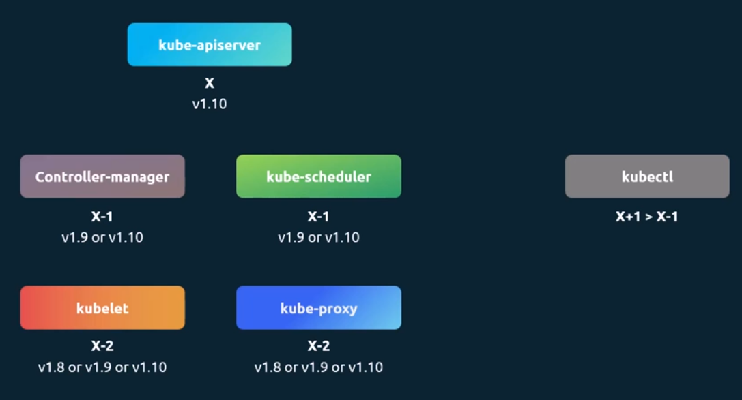
Now this permissible skew in versions allows us to carry out live upgrades. We can upgrade component by component if required.
When should you upgrade? Say you were at 1.10 and Kubernetes releases versions 1.11 and 1.12 at any time. Kubernetes supports only up to the recent three minor versions. with 1.12 being the latest release, Kubernetes supports versions 1.12, 1.11, and 1.10. when 1.13 is released, only versions 1.13, 1.12 and 1.11 are supported. Before the release of 1.13 would be a good time to upgrade your cluster to the next release.
So how do we upgrade? Do we upgrade directly from 1.1 to 1.13? No. The recommended approach is to upgrade one minor version at a time. Version 1.10 to 1.11, then 1.11 to 1.12, and then 1.12 to 1.13.
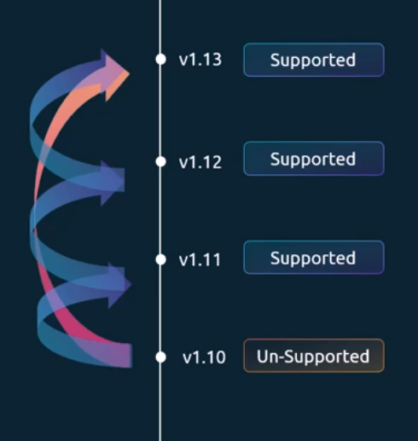
The upgrade process depends on how your cluster is set up. For example, if your cluster is a managed Kubernetes cluster deployed on cloud service providers like Google, for instance, Google Kubernetes Engine lets you upgrade your cluster easily with just a few clicks. If you deployed your cluster using tools like Kube ADM, then the tool can help you plan and upgrade the cluster. If you deployed your cluster from scratch, then you manually upgrade the different components of the cluster yourself. In this lecture we will look at the options by kube adm.
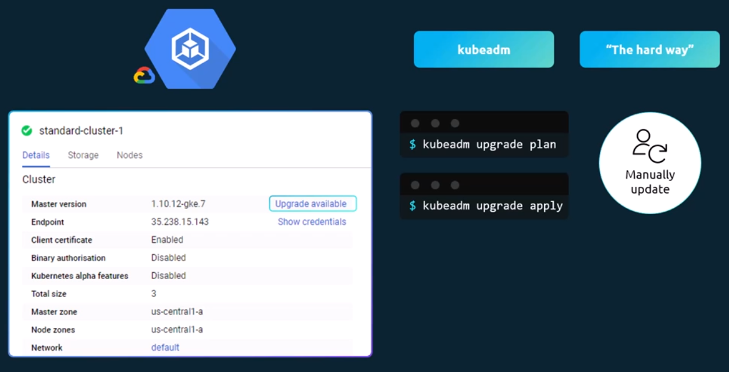
You have a cluster with master and worker nodes running in production, hosting pods serving users. The nodes and components are at version 1.10. When upgrading a cluster involves two major steps. First, you upgrade your master nodes and then upgrade the worker nodes while the master is being upgraded. The control plane components such as the API, server, scheduler, and controller managers go down. briefly, the master going down does not mean your worker nodes and applications on the cluster are impacted. All workloads hosted on the worker nodes continue to serve users as normal. Since the master is down, all management functions are down. You cannot access the cluster using kube control or other Kubernetes APIs. You cannot deploy new applications or delete or modify existing ones. The controller managers don't function either. If a pod was to fail, a new pod won't be automatically created. But as long as the nodes and pods are up, your applications should be up and users will not be impacted. Once the upgrade is complete and the cluster is back up, it should function normally. We now have the master and the master components at version 1.11, and the worker nodes at version 1.10.
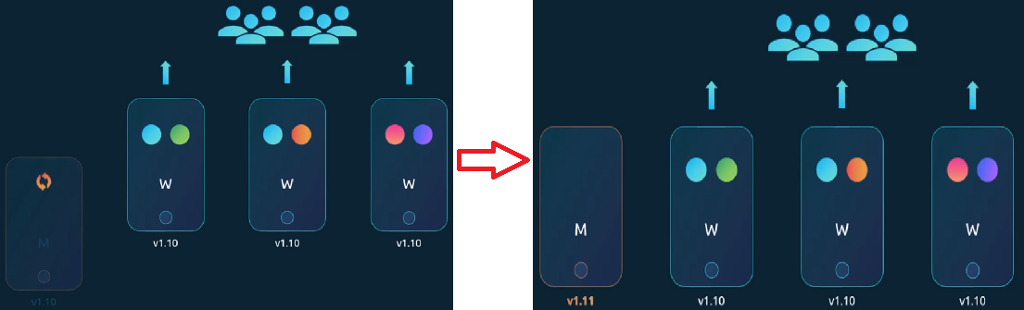
As we saw earlier, this is a supported configuration. It is now time to upgrade the worker nodes. There are different strategies available to upgrade the worker nodes.
One is to upgrade all of them at once, but then your pods are down and users are no longer able to access the applications. Once the upgrade is complete, the nodes are back up, new pods are scheduled, and users can resume access. That's one strategy that requires downtime.
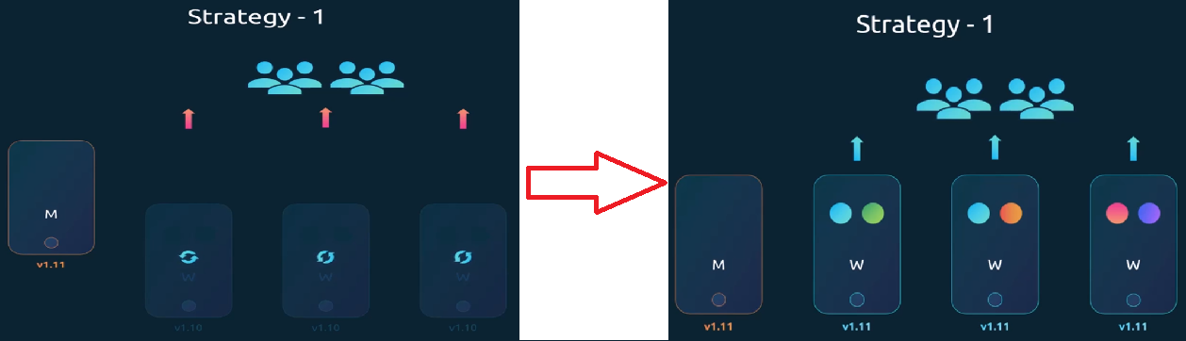
The second strategy is to upgrade one node at a time. So going back to the state where we have our master upgraded and nodes waiting to be upgraded, we first upgrade the first node where the workloads move to the second and third node, and users are served from there. Once the first node is upgraded and back up, we then update the second node where the workloads move to the first and third nodes, and finally the third node where the workloads are shared between the first and two. Until we have all nodes upgraded to a newer version, we then follow the same procedure to upgrade the nodes from 1.11 to 1.12 and then 1.13.
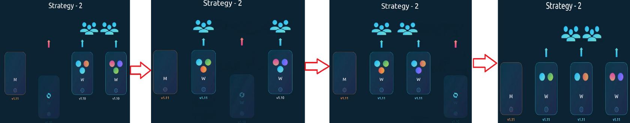
A third strategy would be to add new nodes to the cluster nodes with newer software version. This is especially convenient if you're on a cloud environment, where you can easily provision new nodes and decommission old ones. Nodes with the newer software version can be added to the cluster. Move the workload over to the new. And remove the old node until you finally have all new nodes with the new software version.
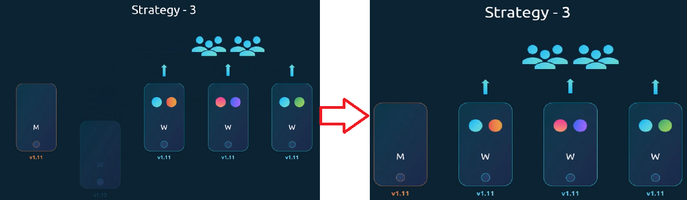
Let us now see how it is done. Say we were to upgrade this cluster from 1.10 to 1.13. Kubeadm has an upgrade command that helps in upgrading clusters with Kubeadm. Run the Kubeadm upgrade plan command and it will give you a lot of good information. The current cluster version. The Kubeadm tool version, the latest stable version of Kubernetes. Then it lists all the control plane components and their versions and what version these can be upgraded to. It also tells you that after we upgrade the control plane components, you must manually upgrade the Kubelet versions on each node. Remember, kube adm does not install or upgrade Cubelets. Finally, it gives you the command to upgrade the cluster. Also note that you must upgrade the cube ADM tool itself before you can upgrade the cluster. The cube ADM tool also follows the same software version as Kubernetes.
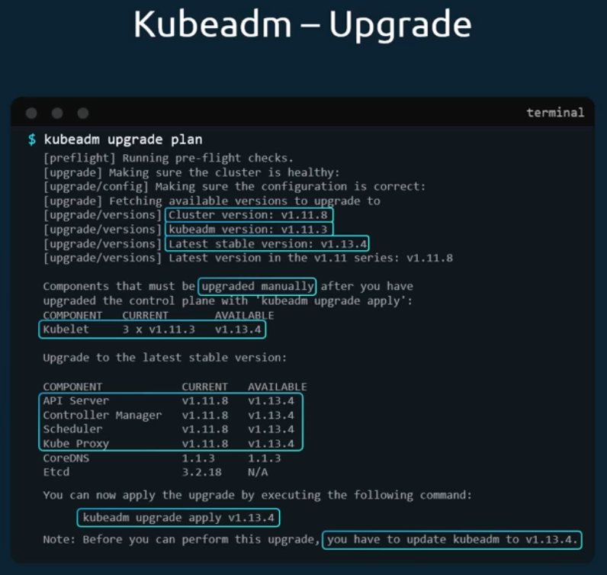
We are at 1.11 and we want to go to 1.13. But remember we can only go one minor version at a time. we first go to 1.1 to first upgrade the cube ADM tool itself to version 1.12, then upgrade the cluster using the command from the upgrade plan output cube upgrade apply. It pulls the necessary images and upgrades the cluster components. Once complete, your control plane components are now at 1.12. If you run the kube control get nodes command, you will still see the master node at 1.17. This is because in the output of this command, it is showing the versions of Kubelets on each of these nodes registered with the API server, and not the version of the API server itself. the next step is to upgrade the Kubelets. Remember, depending on your setup, you may or may not have Kubelets running on your master node. In this case, the cluster deployed with Kube ADM has Kubelets on the master node, which are used to run the control plane components as pods on the master nodes. When we set up a Kubernetes cluster from scratch later during this course, we do not install Kubelet on the master nodes. You will not see the master node in the output of this command in that case. the next step is to upgrade Kubelet on the master node. If you have Kubelets on them, run the apt. Get Kubelet command for this. Once the package is upgraded, restart the Kubelet service.
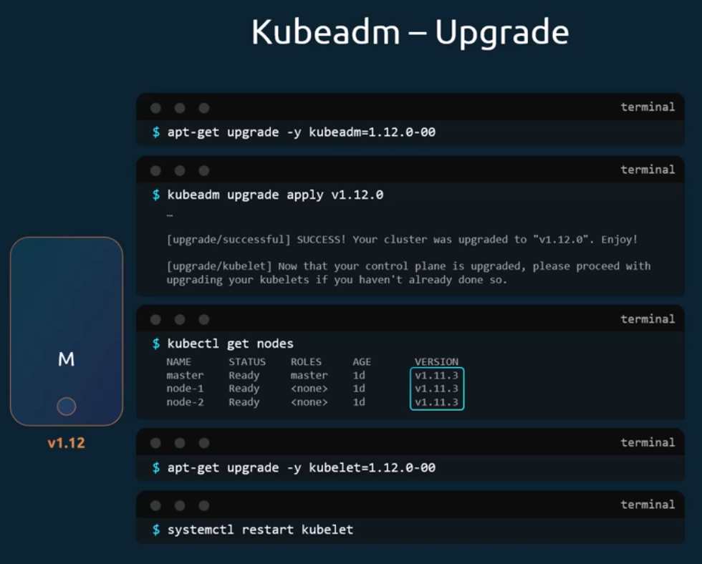
Running the kube control get nodes command now shows that the master has been upgraded to 1.12, The worker nodes are still at 1.11.
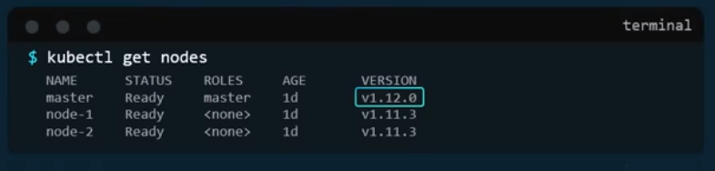
Next the worker nodes let us start one at a time. We need to first move the workloads from the first worker node to the other nodes. The kube control drain command lets you safely terminate all the pods from a node and reschedules them on the other nodes. It also cordons the node and marks it un schedulable. That way no new pods are scheduled on it. Then upgrade the kubectl and kubelet packages on the worker nodes as we did on the master node. Then, using the kube adm tool upgrade command, update the node configuration for the new Cubelet version. Then restart the Cubelet service. The node should now keep up with the new software version.
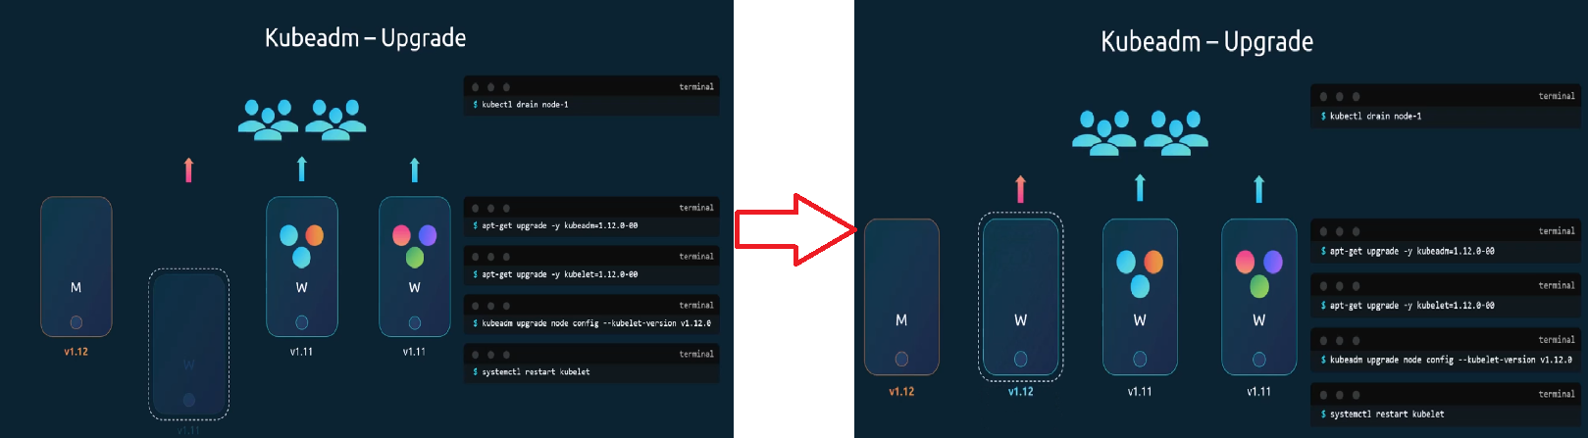
However, when we drain the node, we actually marked it Un schedulable, we need to unmark it by running the command kube control on node one.
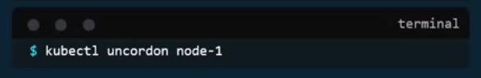
The node is now Schedulable, but remember that it is not necessary that the pods come right back to this node. It is only marked as Schedulable. Only when the pods are deleted from the other nodes, or when new pods are scheduled. Do they really come back to this first node? Well, it will soon come when we take down the second node to perform the same steps to upgrade it. And finally, the third node. We now have all nodes upgraded.
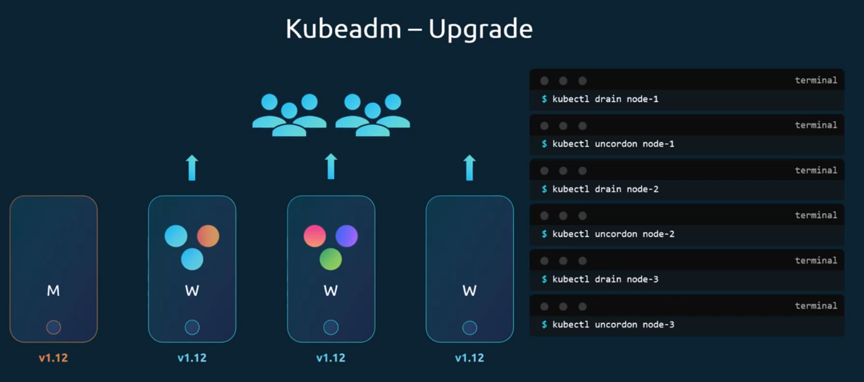
Backup and Restore Methods:
We look at the various backup and restore methodologies. Let's start by looking at what you should consider backing up in a Kubernetes cluster. So far in this course, we have deployed a number of different applications on our Kubernetes cluster using deployment pods and service definition files.
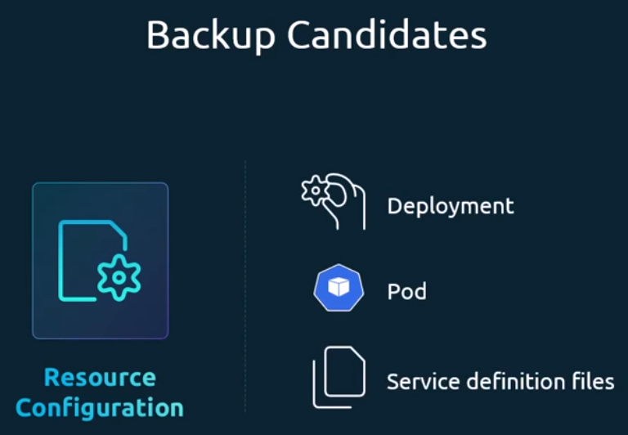
We know that the etcd cluster is where all cluster related information is stored. And if your applications are configured with persistent storage, then that is another candidate for backups.
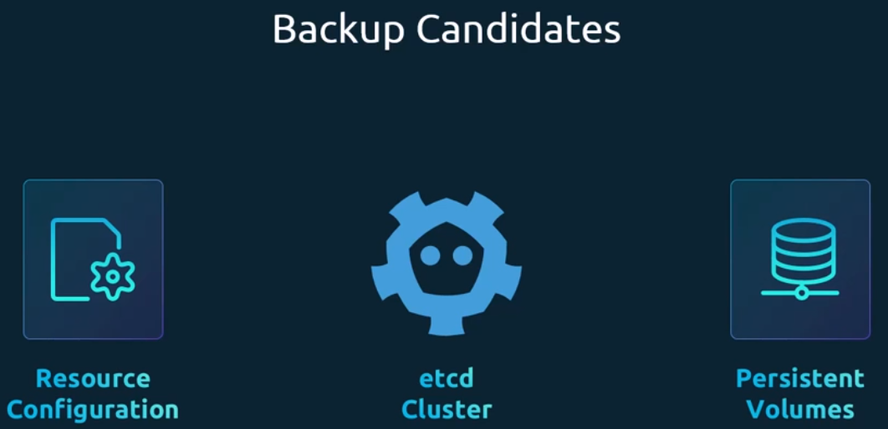
We respect to resources that we created in the cluster; at times we use the imperative way of creating an object by executing a command, such as while creating a namespace or a secret or configmap, or at times for exposing applications.
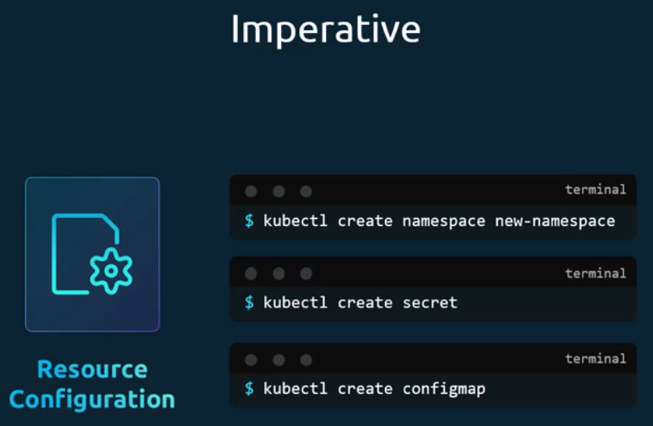
And at times we used the declarative approach by first creating a definition file and then running the kube control apply command on that file.
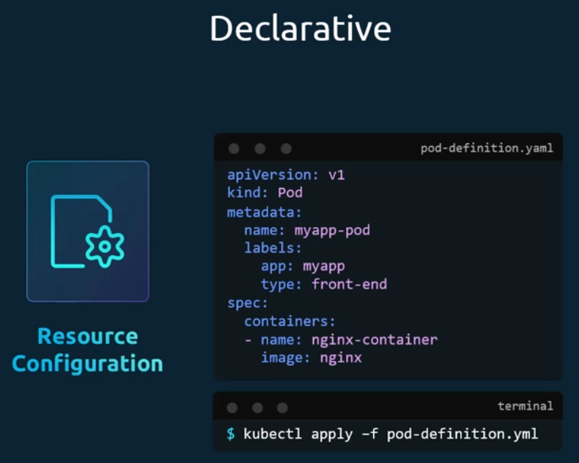
This is the preferred approach if you want to save your configuration, because now you have all the objects required for a single application in the form of object definition files in a single folder. This can easily be reused at a later time or shared with others. Of course, you must have a copy of these files saved at all times.
A good practice is to store these on source code repositories. That way it can be maintained by a team. The source code repository should be configured with the right backup solutions, with managed or public source code repositories like GitHub. You don't have to worry about this. With that, even when you lose your entire cluster, you can redeploy your application on the cluster by simply applying these configuration files on them.
While the declarative approach is the preferred approach, it is not necessary that all of your team members stick to those standards. What if someone created an object the imperative way without documenting that information anywhere? a better approach to backing up resource configuration is to query the cube API server, query the kube API server using the cube control, or by accessing the API server directly, and save all resource configurations for all objects created on the cluster as a copy. For example, one of the commands that can be used in a backup script is to get all pods and deployments and services in all namespaces using the kube control utilities.
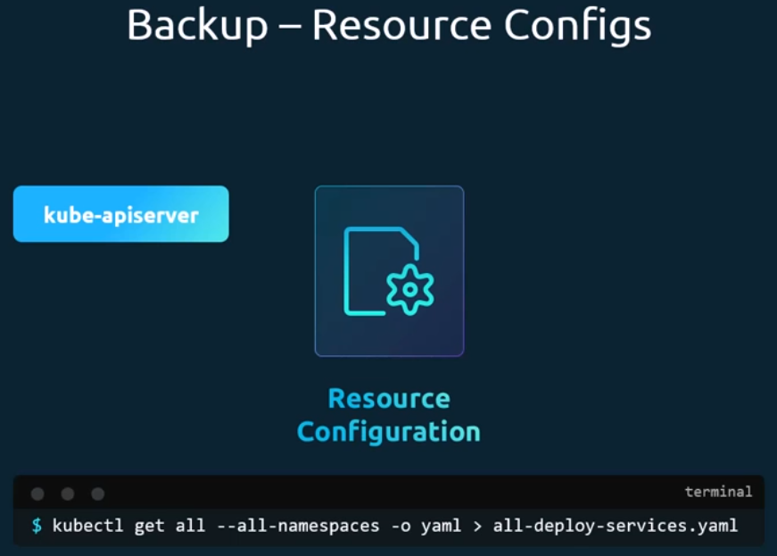
Get all command and extract the output in YAML format, then save that file. And that's just for a few resources group.
There are tools like Arc or now called Valero by Heptio that can do this for you. It can help in taking backups of your Kubernetes cluster using the Kubernetes API.
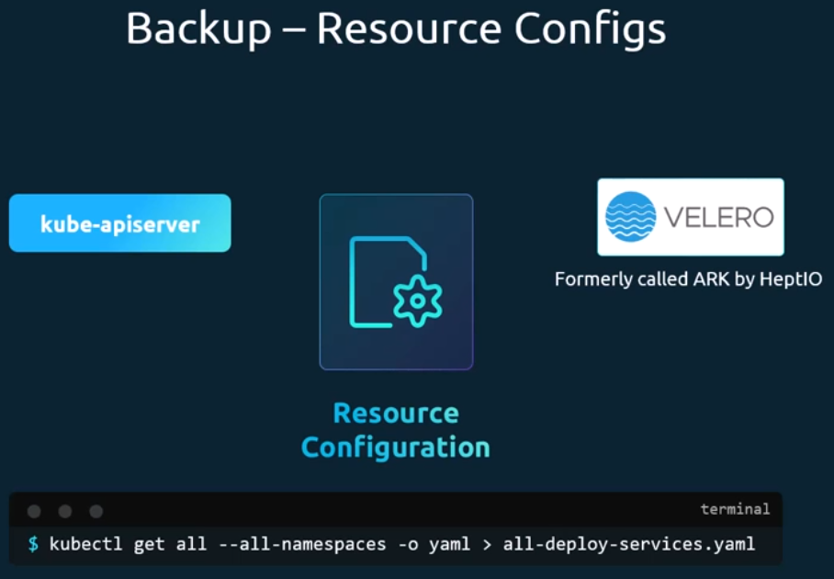
Let us now move on to etcd. The etcd cluster stores information about the state of our cluster. information about the cluster itself, the nodes and every other resource created within the cluster are stored here. instead of backing up resource as before, you may choose to back up the etcd server itself. As we have seen, the etcd cluster is hosted on the master nodes. While configuring etcd, we specified a location where all the data would be stored. The data directory that is, the directory that can be configured to be backed up by your backup tool.
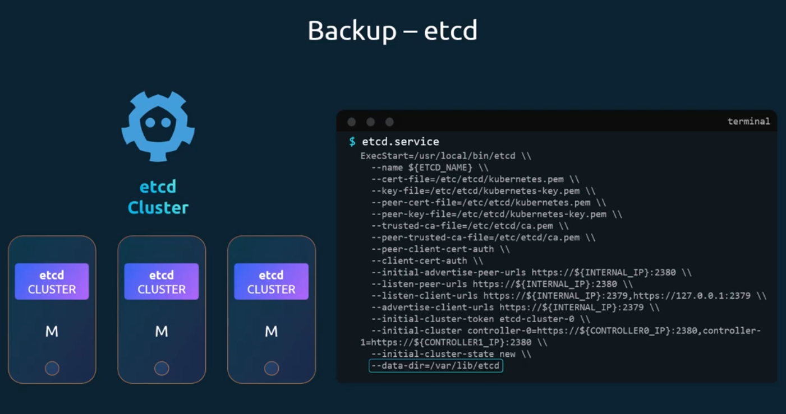
Etcd also comes with a built-in snapshot solution. You can take a snapshot of the etcd database by using the etcd control utilities Snapshot save command.
Give the snapshot a name. Snapshot A snapshot file is created by the name in the current directory. If you want it to be created in another location, specify the full path. You can view the status of the backup using the snapshot status command.
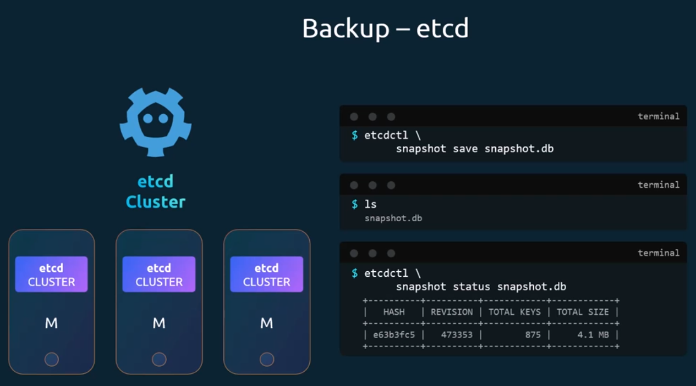
To restore the cluster from this backup at a later point in time. First stop the kube API server service, as the restore process will require you to restart the etcd cluster and the API server depends on it. Then run the etcd controls snapshot restore command with the path set to the path of the backup file, which is the snapshot db file. When etcd restores from a backup, it initializes a new cluster configuration and configures the members of etcd as new members to a new cluster.
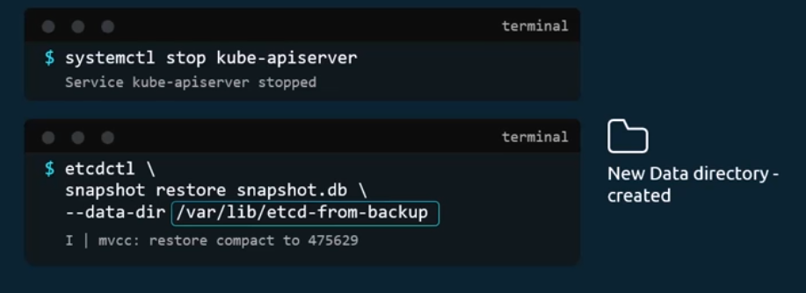
This is to prevent a new member from accidentally joining an existing cluster on running this command. A new data directory is created in this example at location var lib etcd from backup. We then configure the etcd configuration file to use the new data directory.
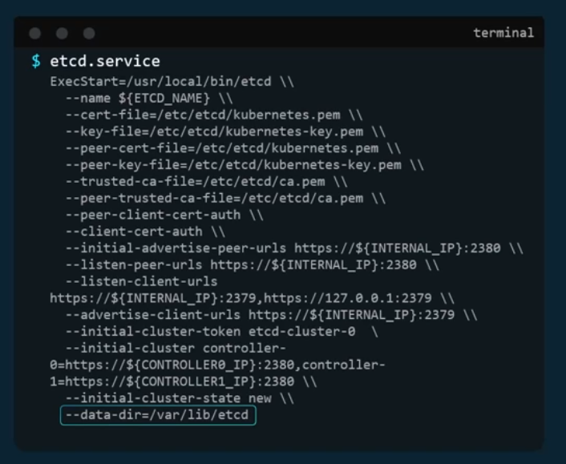
Then reload the service daemon and restart etcd service. Finally, start the kube API server service. Your cluster should now be back in the original state.
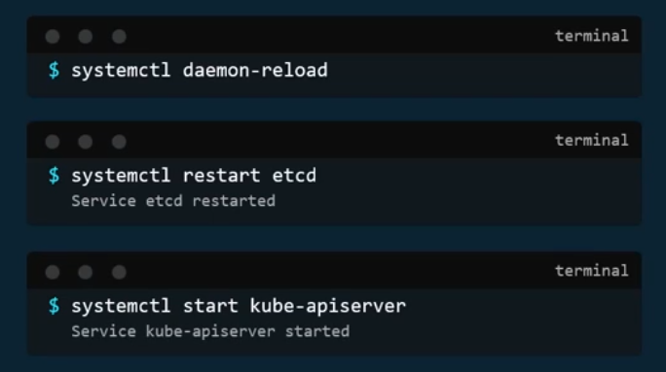
A quick note before I let you go with all the etcd commands, remember to specify the certificate files for authentication. Specify the endpoint to the etcd cluster and the certificate, the server certificate and the key.
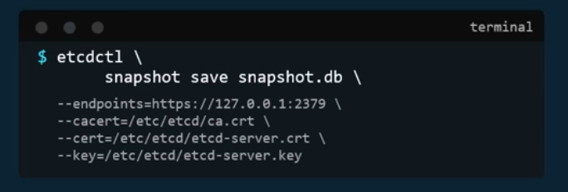
We have seen two options a backup using etcd and backup by querying the kube API server. Now both of these have their pros and cons.
If you're using a managed Kubernetes environment, then at times you may not even have access to the etcd cluster. In that case, backup by querying the kube API server is probably the better way.

